NAME______________________________Lab Meeting day/time_____­­­________

Lab 1, Part 2 -KEY

For the second part of Lab 1, you will complete Exercise 11 in your lab manual. A copy of this lab will be provided this week for those of you that do not yet have a manual.

You will record your answers on this document. Be sure to read ALL text of the lab as you work through the exercise – there is valuable information in the readings that will help you complete the exercises. **BELOW, WRITE YOUR ANSWERS AS DIRECTED IN THE LAB.** Alternatively, you could complete this exercise in your lab book and tear out and submit the answers (but, don’t do this if you plan on reselling your book after the semester is over!)

# **PART A – SKIP this Part**

You may skip this exercise. The idea is to recognize that the continents fit together like a jigsaw puzzle, when comparing their shape at the continental shelf And that rock ages and types are similar where the continents match together. We will explore this idea more in lecture.

# **PART B – Seafloor Spreading and the magnetic timescale**

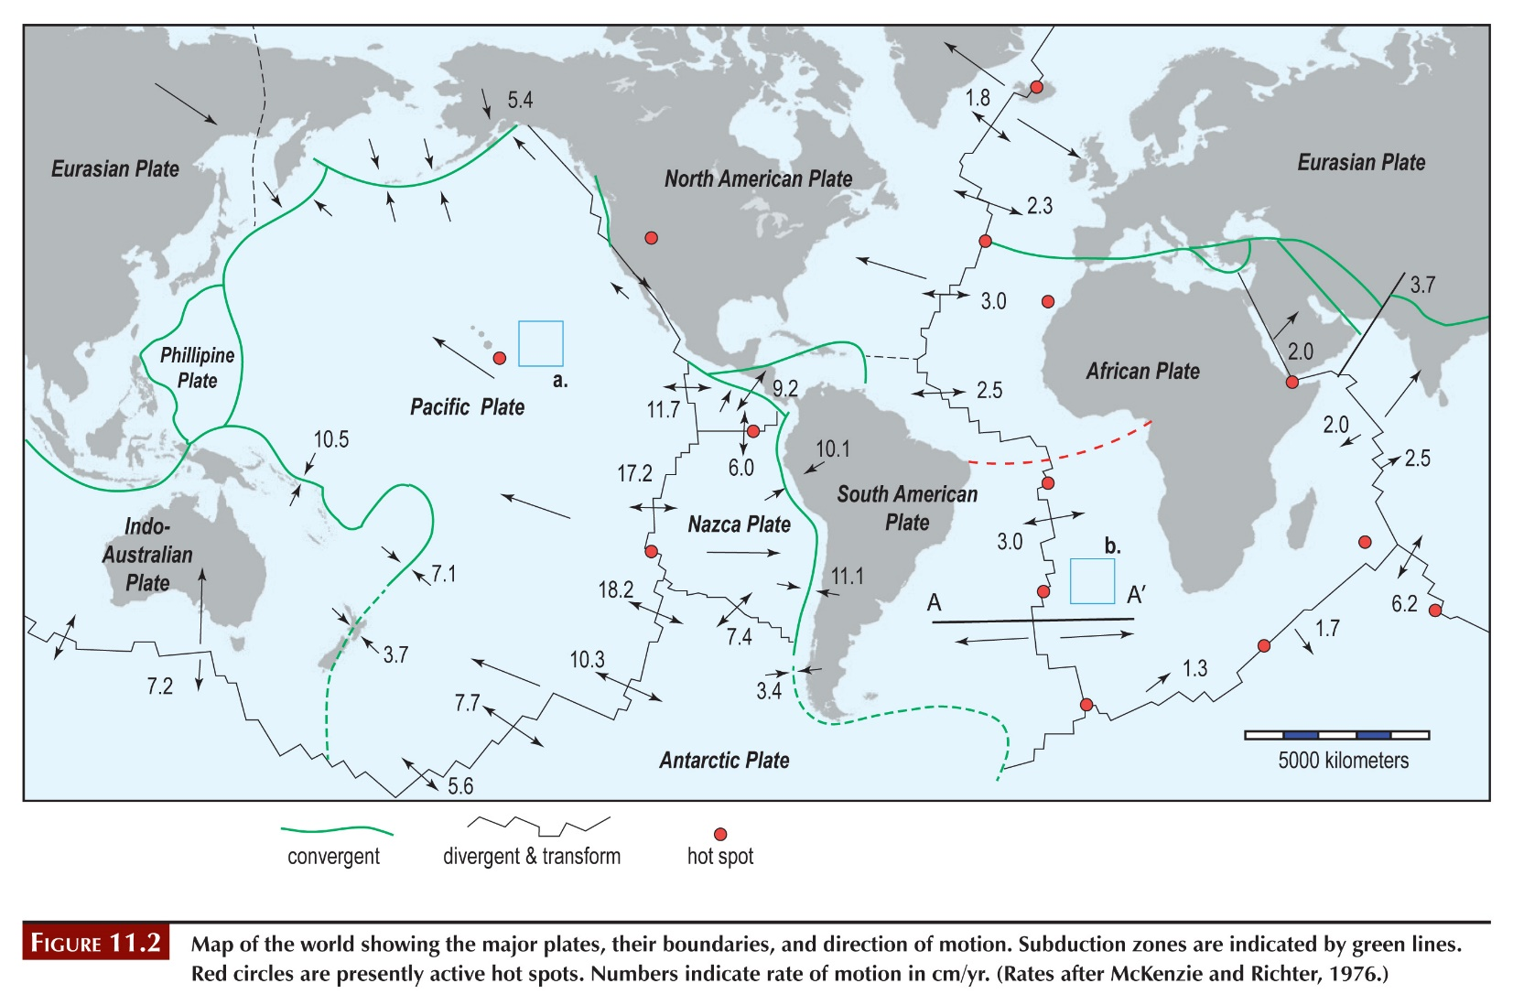

**1.**

***Indicates seafloor spreading; as new rock is formed at the ridge, it records the polarity. The alternating patterns show rock is forming at the ridge and moving away.***

**2. Show your work**

***100 km (10 million cm) in 5.5 million years = 1.82 cm/yr (students should show how they arrived at this number)***

**3. Label on figure above.**

***Should write 1.82 in box b on the figure.***

**4. Show your work.**

***Approximately 5,000 km separate Africa and South America along the red dashed line in figure 11.2. Hence, Africa and South America have each travelled 2,500 km from the Mid-Atlantic Ridge. 250 million cm / 1.82 cm/yr = 139 million years. This suggests that separation of Africa and South America (rifting of Pangea) commenced during early Cretaceous time***

**5. Explain your answer.**

***Point A = 4.25 million years old. Point B = 5.5 million years old.***

***Students should explain how they arrived at these answers.***

# **PART C – Characteristics of plate margins**

Use figure 11.2, your text, and online searches to complete the table.

**The following table lists possible answers:**

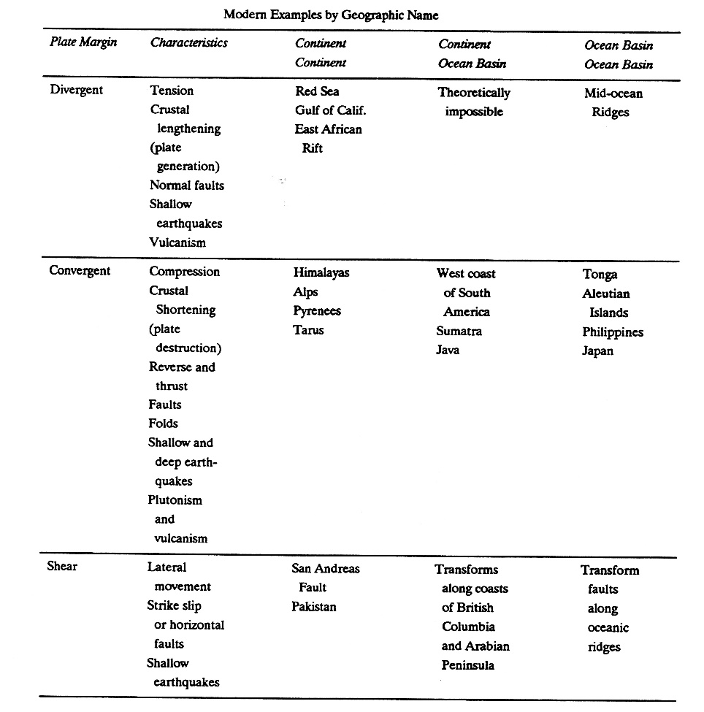

# **PART D – Locating plate margins**

**1. Complete on figure below using the instructions.**

***Students should plot data on this map, showing a pattern of earthquakes that outline the plate boundaries.***

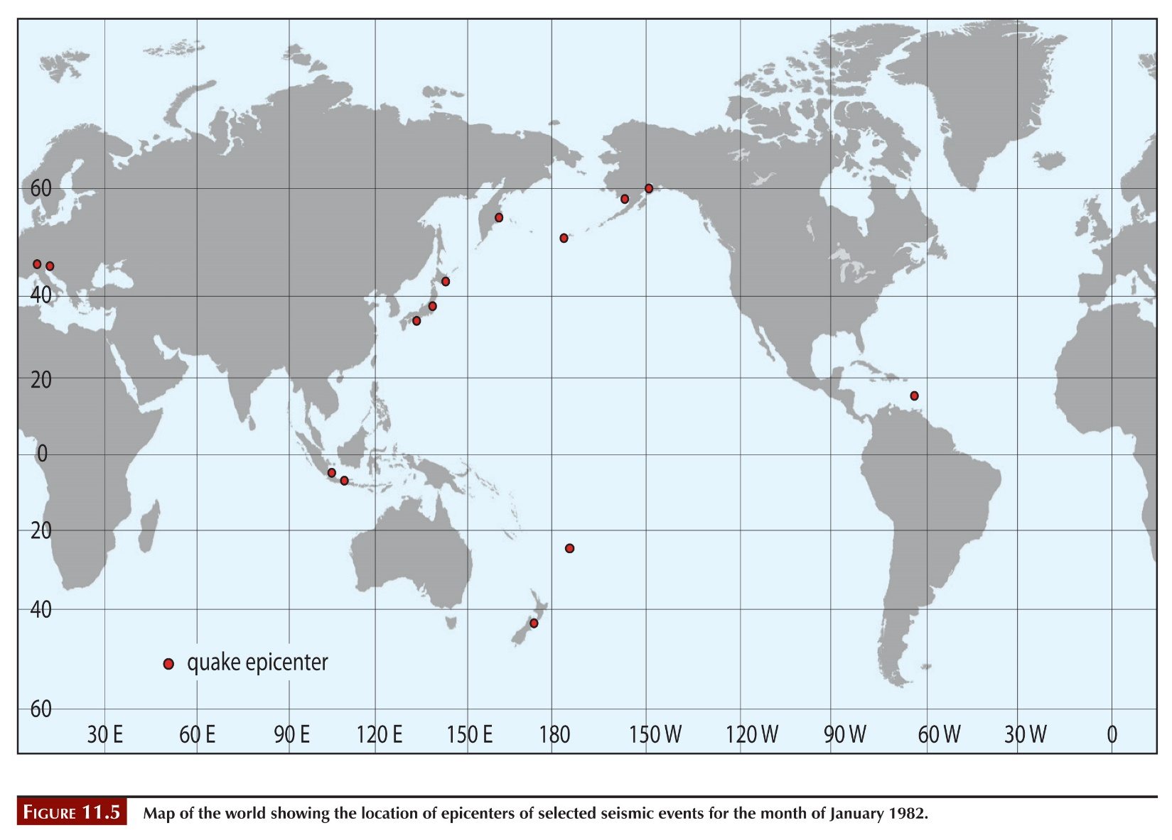

**2.**

***Of the 89 epicenters, 23 are intermediate depth and two are deep focus earthquakes. All intermediate and deep foci quakes are located along convergent plate margins, reflecting the descent of the subducting plate. The student will see this best along the South American and Alaskan coasts where the intermediate foci are offset inland over the subducting plate.***

**3.**

***The Bonin Islands are situated on the juncture of the Japan and Mariana trenches (a subduction zone where one plate is subducted under the other); therefore deep foci earthquakes are to be expected from the subducting slab.***

**4.**

***This is a record of a Soviet-era nuclear explosion at a test facility in the former USSR. The location, in a seismically quiet zone, plus the zero depth of the hypocenter should be the basis for their answer.***

# **PART E – HOT SPOTS AND PLATE MOTION**

**1. Plot on the figure below, following the instructions.**

***Should draw line as indicated, direction of plate movement is northwest***

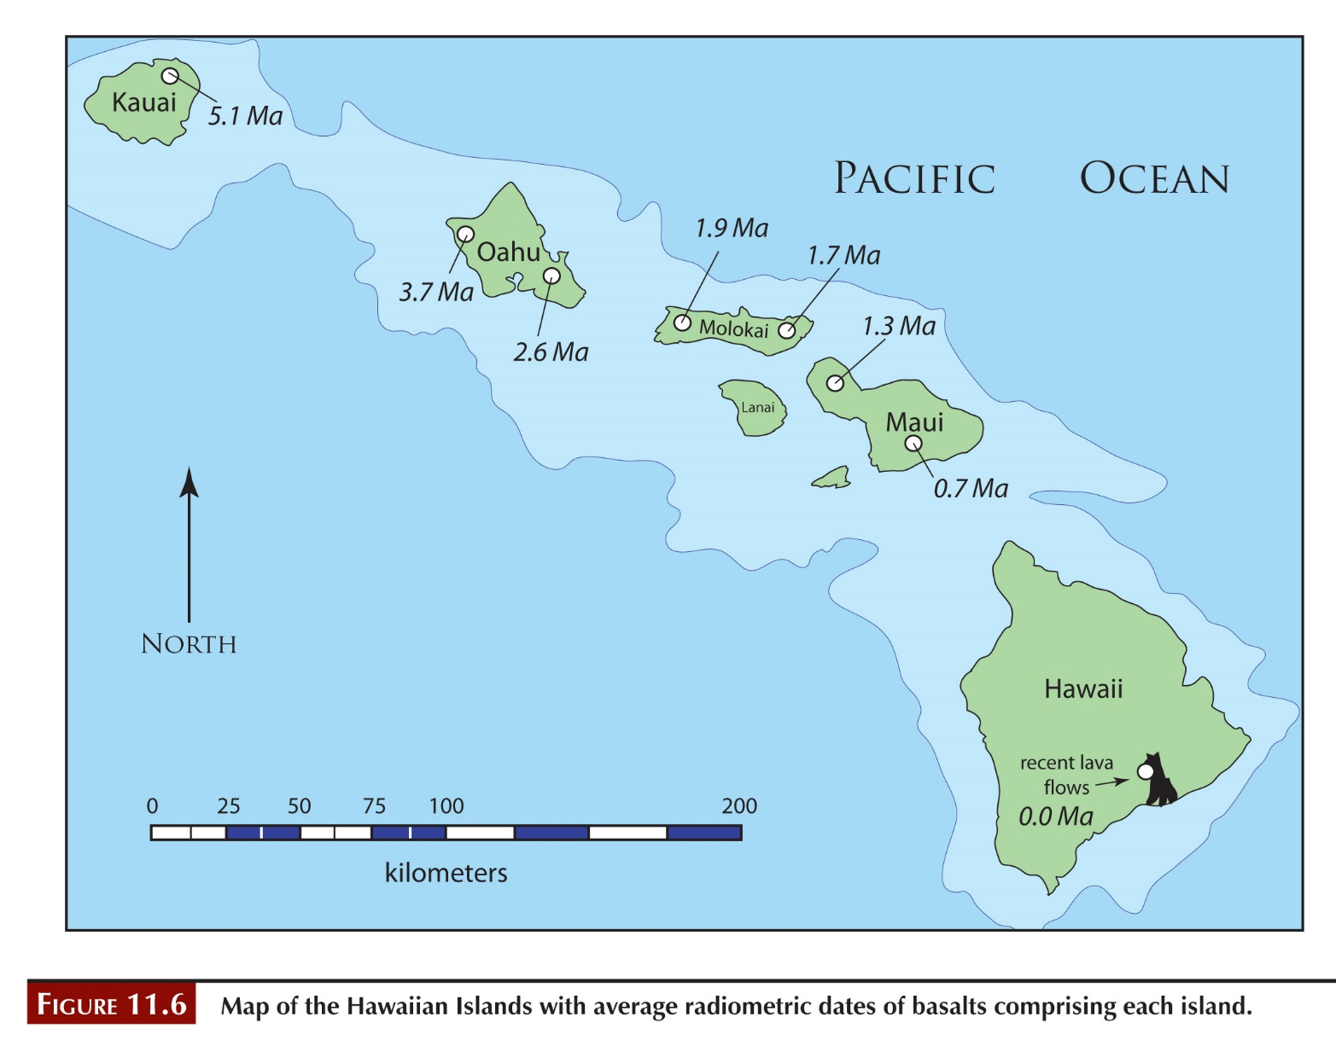

**2. Use instructions to fill in table below.**

**See table below.**

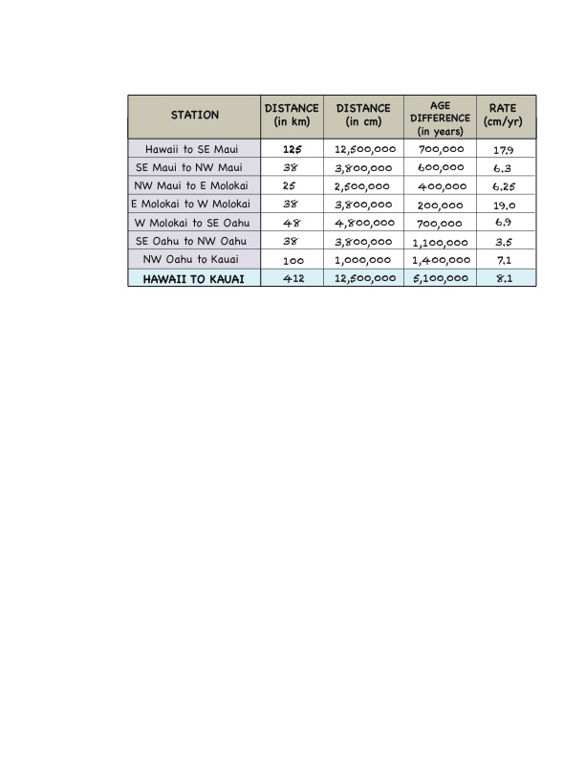

**3.**

***No, it has not been constant. It has ranged from 3.5 to 19 cm/year***

**4. Enter in figure on Part B.**

***The average rate was 8.1 cm/yr for the past 5.1 million years.***

***Should write this in the box labeled a on the first page of the lab.***

# **PArt F – Plate tectonics and the aleutian islands**

**1. Plot on the figure here.**

***Figure should look similar to below with labeled points as red and green dots, line showing dip, and plate movements***

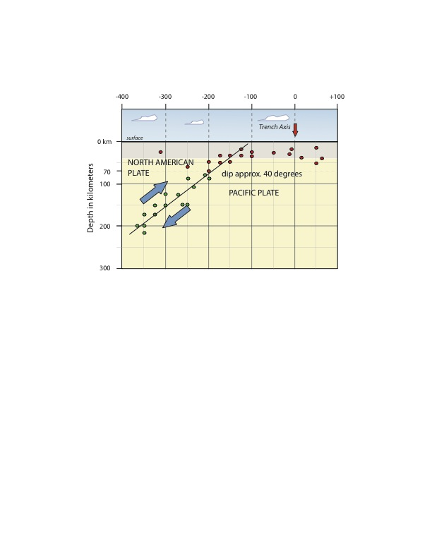

**2.**

***Convergent***

**3.**

***10 to 220 kilometers depth***

**4.**

***Because this is where the place is dipping (subducting)***

**5.**

***About 40 degrees***

**6. Label on the figure you drew in number 1.**

***Should include labels for North American Plate and Pacific Plate on figure above.***

# **Post lab reflection**

**What concepts were most difficult in today’s lab activities?**

***Any answers are okay here. If several students comment on same difficulties, perhaps discuss in next class. Also let me (Jenny) know so I can address those concepts in lecture.***

**What concepts were easiest to grasp?**

**What questions did today’s activities make you think of? What do you want to learn more about?**